

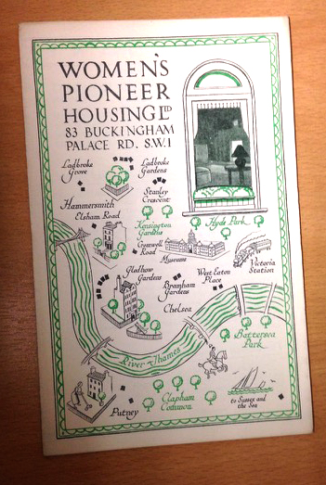
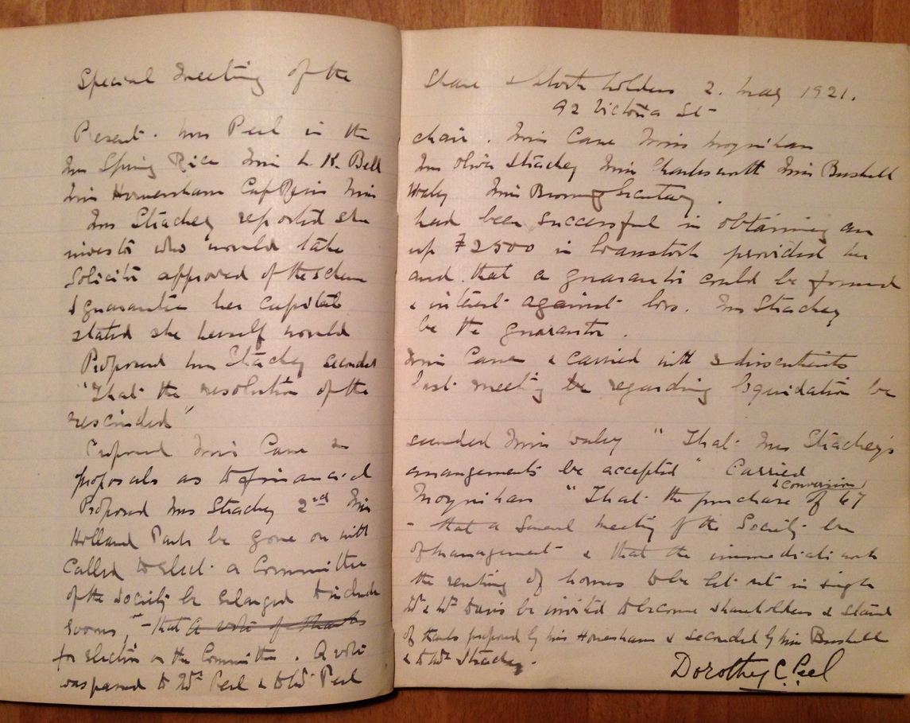

SHARED LEARNING PROJECT: APRIL TO JUNE 2017
PIONEERS OF WOMEN’S HOUSING - FOR THE NEW MODEL WORKING WOMAN
The early history of Women’s Pioneer Housing
Background: WW1 saw the campaign for equal voting rights with men put on ice. Women instead took on the work men had been doing, jobs it was once thought far beyond the mental and physical capacity of women. Peace came at a price. Wartime casualties had left one in three women with no means of support but millions of women were being laid off to make jobs available to ‘returning heroes’. Those desperate to hold on to their job, or to find work to support themselves, flooded the agencies that had placed women in jobs during the conflict. High on the list of what they desperately needed was a decent place they could call home. Etheldred Browning, an Anglo-Irish suffragist who had recently moved to London, observed that in central London many large houses, designed to function on the back of cheap female labour, now lay empty. Women in the war years had tried alternatives to the badly paid, long hours of domestic drudgery. They weren’t going back to it. Etheldred came up with a plan to buy the houses cheaply and convert them into self-contained flats for women. Her tenants could decorate them to their own tastes, the rents would be moderate and there’d be no silly bars on visitors. Despite some very hairy moments, the new ‘Women’s PIoneer Housing’ proved a success with the active support of a network of veterans from the women’s suffrage movement. Old records recently found in Women’s Pioneer’s safe read like a Who’s Who of the suffragist movement, spanning Ireland, Scotland, England and Wales. They reveal too that the women who supported her project or were housed or employed by it, included some of the first to qualify in professions where women are now accepted as the norm. What we have found is a forgotten chapter in suffrage history that shows how the suffragists turned skills honed campaigning for the vote to another practical purpose, helping protect and progress advances women were making in the workplace. We have a cracking story to tell but need help properly researching it.

The project: We need help:
- reading through archive material to draw up an accurate record of who did what and when. The material will be digitally scanned so this can be done on a computer at home.
- researching individual women to find out more about their lives, specifically: their family background, their education/training, the work they did (paid or unpaid) up to and during the 1920s/30s. A lot of this can be done at home using geneology websites (we’re paying for the subscription) or at the Women’s Library, National Archives, university archives or from online archive material provided by trade bodies. Photos would be a huge plus.
- researching one or more professions that opened up to women post-WW1 or that changed significantly (new technology/materials or much tighter professional standards). What factors helped or hindered women’s progress (for example new laws) and how was the contribution of women valued and rewarded compared with that of men. Again archives, universities and trade bodies may help. Family anecdotes welcome!

You should apply if:
- you are interested in the suffrage movement and/or a period of British history that spans the final years of the struggle for Irish independence, world war one and interwar politics
- you are comfortable using the internet and are up to the challenge of trying to get information from geneology websites, where names are often misspelt or a search one day will throw up information that failed, using exactly the same tactics, the day before
- you enjoy detective work, making discoveries and joining the dots in a complex puzzle
- you have time to spare for our project during April, May and June
- you can attend two meetings in April (dates to be decided)
- you are willing to produce reports detailing what you found and where, including full details of your sources and who, if anyone, is to be credited for information and/or images.

Venues: The first meeting will be held at Women’s Pioneer’s offices in White City at 227 Wood Lane, London W12 0EX (nearest tube station is White City, Central line). The second will be held at the Women’s Library at the London School of Economics, 10 Portugal Street, Holborn, London WC2A 2HD (nearest tube is Holborn, Central and Piccadilly lines). Additional research may need to be done at the National Archives (Richmond Road, Twickenham TW9 (nearest station: Kew Gardens overground), the British Library and
Royal Holloway/University of London. Most other research can be done online.

Questions and applications by Tuesday 28 February or earlier to:
Lisa Thompson thompsonstwo@icloud.com 01732 750 433 Or text 07885 519 117
Jo Walters jo.walters.slp@gmail.com 01689 854880. Or text 07713916620
Dionne Antrobus Dionne.Antrobus@womenspioneer.co.uk 020 8749 7112

